Target Audience 18-32

Our reasoning for this particular target audience is that there are not many top-down shooters made in the current day however with older console generations they were more common as either a traditional top-down shooter or a ShMUp (Shoot eM Up) these always took plase on a 2d plane with no control of the speed of screen movement and revolved around combatting waves of enemies whilst dodging projectiles one of the only ones still within common knowlege now is Touohou project (pictured below) for the singular fact that is is known to be a ludicrously difficult bullet hell game.

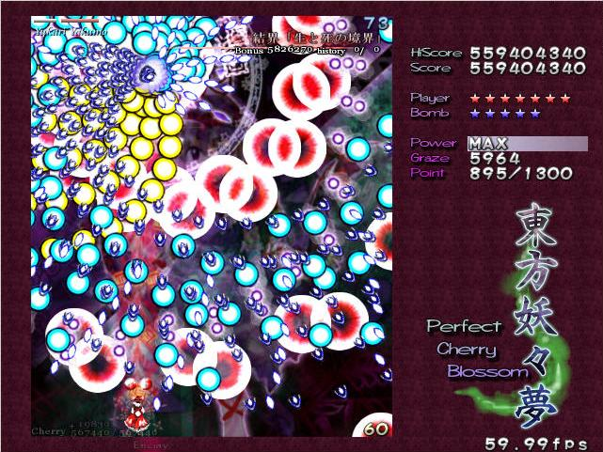

The first shmup

Whilst it is debated wheter space invaders is the first ShMUp it is widely agreeed that whilst it did help it doesn’t fit the sub genre enough to be considdered one. Galaxians (pictured below) was releaced in 1979

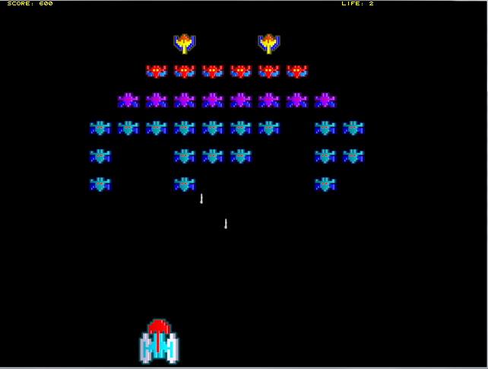

and is considered to be the first in the genre how ever it is not remembered as fondly as Gradius (pictured below)

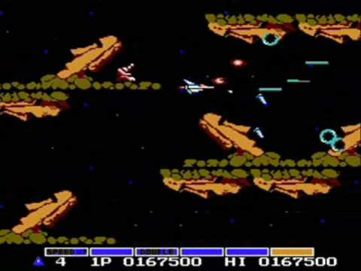

This is not only praised for the high visual fidelity at the time but also for being a good definer for ShMUps as a whole.

Top down shooters on the other had didn’t have as much popularity back in the NES/SNES days but have more recently made a resergence with games like hotline miami and the binding of issac (both pictured below)

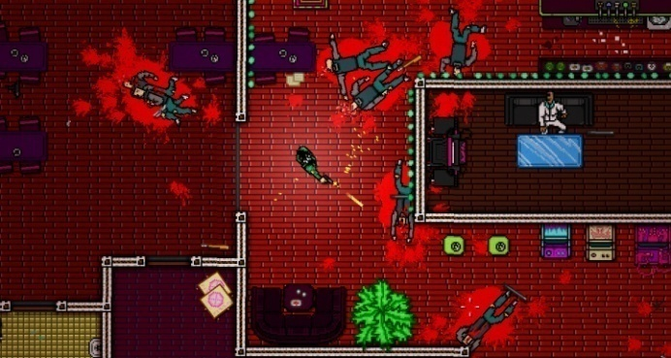 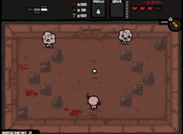

The top down shooter has less genre spesification compared to alot of other genres requireing only that you shoot and see things from a top down perspective

The origional metal gear solid (pictured below) despite being focused on stealth is considered a top down shooter (due to the more leanient catagorisation) the same as the games mentioned previously.

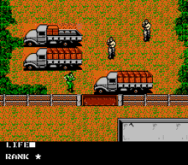

Unfortunately due to the lack of popularity there is not as much data on old down shooters.

The audience for these types of games want predictable actions done by the ai and controls that are entirely reliable as these core prinsaples are what make memorable games on top of this is consistiency and a fast itteration time as these allow for mastery of a game.

The reason we chose a top down shooter is that those aspects were easy to design arround and alowed alot more creative freedom then other genre

Bibliography

<http://www.nullpointer.co.uk/content/endless-fire-a-history-of-the-shmup/>